**DAILY ONLINE ACTIVITIES SUMMARY**

|  |  |  |  |  |  |
| --- | --- | --- | --- | --- | --- |
| **Date:** | | **19 June 2020** | **Name:** | **KHATHEEJA SAFREENA.** | |
| **Sem & Sec** | | **4th sem, 2nd year** | **USN:** | **4al18cs037** | |
| **Online Test Summary** | | | | | |
| **Subject** | **MICROCONTROLLER AND EMBEDDED SYSTEMS (18cs44)** | | | | |
| **Max. Marks** | **20** | | **Score** | **18** | |
| **Certification Course Summary** | | | | | |
| **Course** | | **Introduction to Cyber Security.** | | | |
| **Certificate Provider** | | **GreatLearning** | **Duration** | | **12 hours** |
| **Coding Challenges** | | | | | |
| **Problem Statement:3 program** | | | | | |
| **Status: Executed** | | | | | |
| **Uploaded the report in Github** | | | **Yes** | | |
| **If yes Repository name** | | | [http://shafreenasharief / lockdown-coding](http://shafreenasharief / lockdown-coding" \o "http://shafreenasharief / lockdown-coding)  [http://shafreenasharief / locked-down--certification-course](http://shafreenasharief / locked-down--certification-course" \o "http://shafreenasharief / locked-down--certification-course)  [http://shafreenasharief / Daily\_Report](http://shafreenasharief / Daily_Report" \o "http://shafreenasharief / Daily_Report) | | |
| **Uploaded the report in slack** | | | **Yes** | | |

Online Test Details: (Attach the snapshot and briefly write the report for the same)

Certification Course Details: (Attach the snapshot and briefly write the report for the same)

Coding Challenges Details: (Attach the snapshot and briefly write the report for the same)

**ONLINE TEST SUMMARY:**

#### Today MICROCONTROLLER AND EMBEDDED SYSTEMS (18cs44) exam was conducted for 20 marks for duration of 30 min.

#### 

#### CERTIFICATION COURSE SUMMARY:

Today I started new course INTRODUCTION TO INFORMATION SECURITY through GREAT LEARNING the course is secluded for 6hrs. After the completion of course, certificate will be provided. I completed all the module .I attempted quiz ,which gave me a clear veiw about the topics that were thought and discussed.It consists of 7 modules which also include assessments.

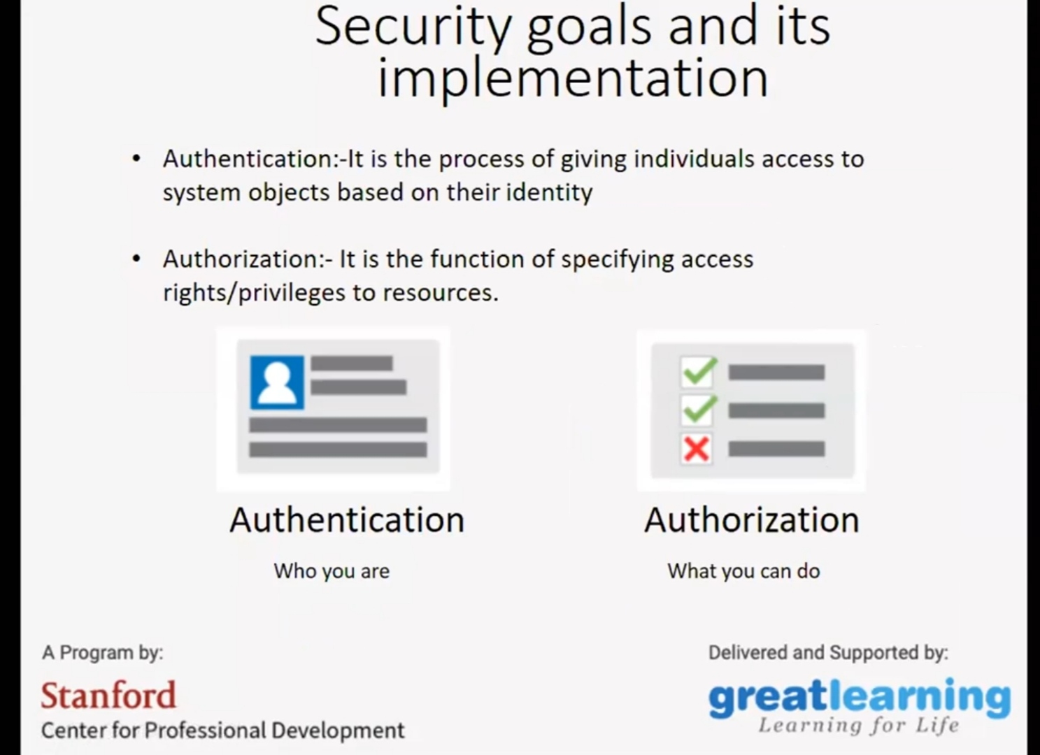

**CODING CHALLENGES**

Today I solved 2 coding challenge,

**Problem Statement 1**:

**Write a C Program to Count total set bits in all numbers from 1 to n**

Given a positive integer n, count the total number of set bits in binary representation of all numbers from 1 to n.

**Examples:**

Input: n = 3  
Output: 4  
Input: n = 6  
Output: 9

**Hint:** Read a positive integer (example: 3 indicates range), so u have to consider 1, 2, 3 as the input convert these numbers into binary and count the number of 1 in that (1- 0001, 2- 0010, 3- 0011) number of 1s from all 3 digit is 4 so the answer is 4.

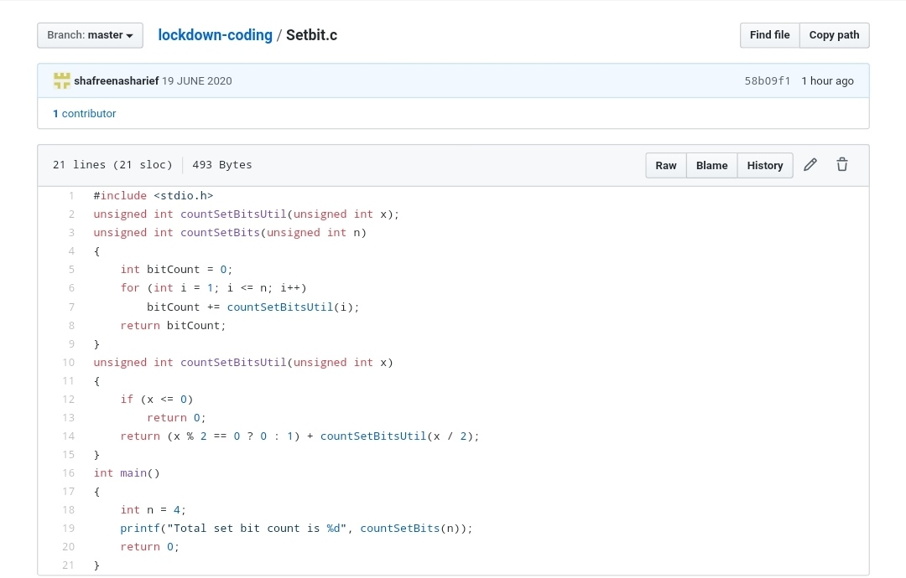

**Problem Statement 2:**

**Write a C Program to rotate a Matrix by 90 Degree in Clockwise or Anticlockwise Direction.**

Matrix Rotation by 90 Degree in Clockwise Direction:

Input:  
Enter the total Number of Rows m: 3  
Enter the total Number of Columns: 3  
Enter the Elements of the Matrix:  
1 2 3 4 5 6 7 8 9  
Output:  
The Given Matrix is:  
1 2 3  
4 5 6

7 8 9  
The Output Matrix After Rotation by 90 Degree in Clockwise Direction is:  
7 4 1  
8 5 2  
9 6 3

Matrix Rotation by 90 Degree in Anticlockwise Direction:

Input:  
Enter the total Number of Rows m: 3  
Enter the total Number of Columns: 3  
Enter the Elements of the Matrix:  
1 2 3 4 5 6 7 8 9  
Output:  
The Given Matrix is:  
1 2 3  
4 5 6  
7 8 9

The Output Matrix After Rotation by 90 Degree in Clockwise Direction is:  
3 6 9  
2 5 8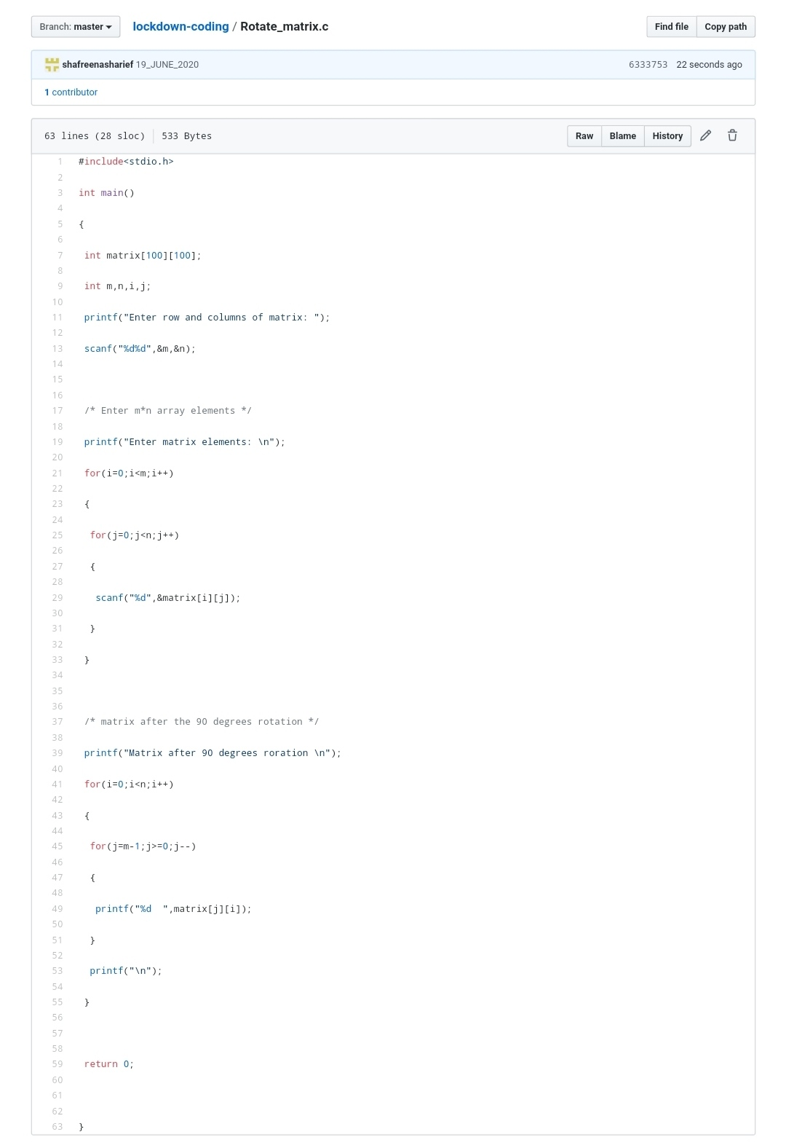  
1 4 7

**Problem Statement 3**:

**Find the smallest positive integer value that cannot be represented as sum of any subset of a given array sorted in ascending order.**

Given a sorted array (sorted in non-decreasing order) of positive numbers, find the smallest positive integer value that cannot be represented as sum of elements of any subset of given set  
**Examples**:

Input: arr [] = {1, 3, 6, 10, 11, 15};  
Output: 2  
There are no one or more elements to be added up to get sum = 2

Input: arr [] = {1, 1, 1, 1};  
Output: 5  
1 = 1, 1+1 = 2, 1+ 1 + 1 = 3, 1 + 1 + 1 + 1 = 4,  
There is no elements in the array to get sum 5

Input: arr[] = {1, 1, 3, 4};  
Output: 10  
1 = 1, 1 + 1 = 2, 3 = 3, 1 + 3 = 4, 1 + 4 = 5, 1 + 1 +4 = 6, 3 + 4 = 7........  
To get sum 10, there is no elements in the array.

Input: arr[] = {1, 2, 5, 10, 20, 40}  
Output: 4  
There are no elements to get sum = 4.

Input: arr [] = {1, 2, 3, 4, 5, 6}  
Output: 22

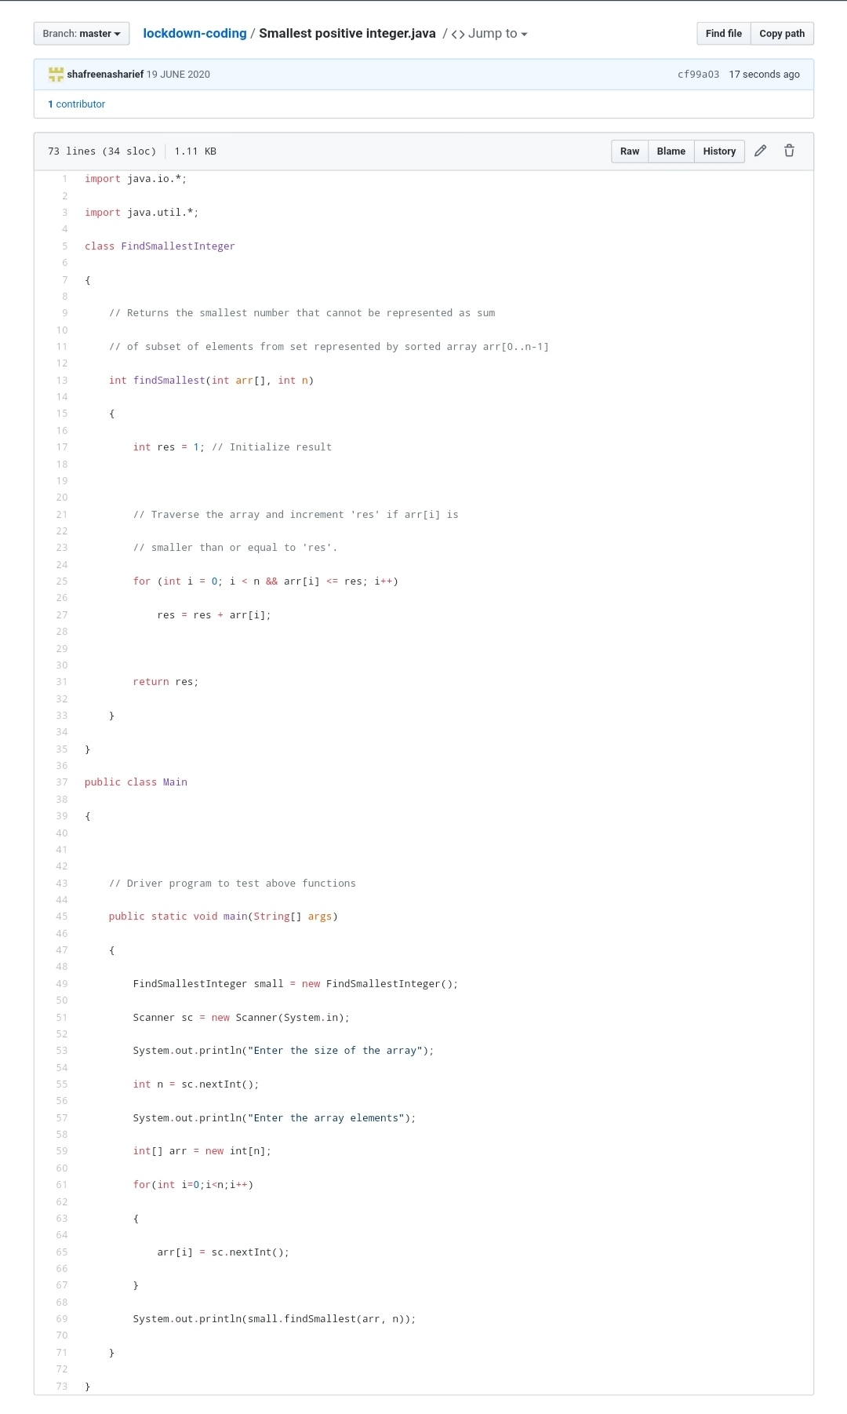

**SOLUTION : I have uploaded the solution of the above 3 coding problems in my GitHub repository.**

**http://shafreenasharief / lockdown-coding**

**http://shafreenasharief / locked-down--certification-course**

**http://shafreenasharief / Daily\_Report**